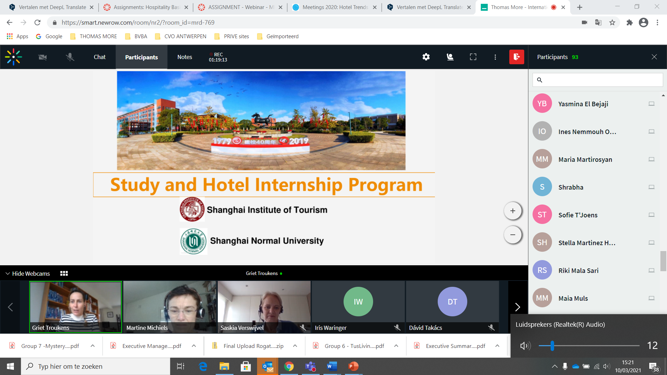

**Celia Wang – Internship possibility China, Shanghai**

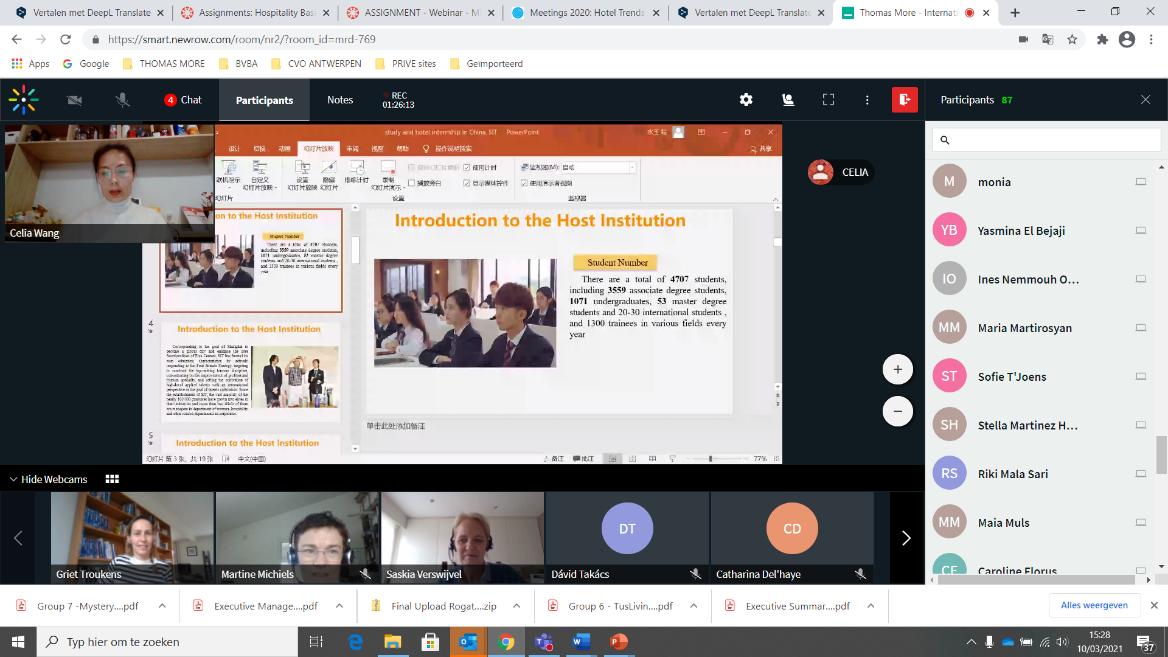

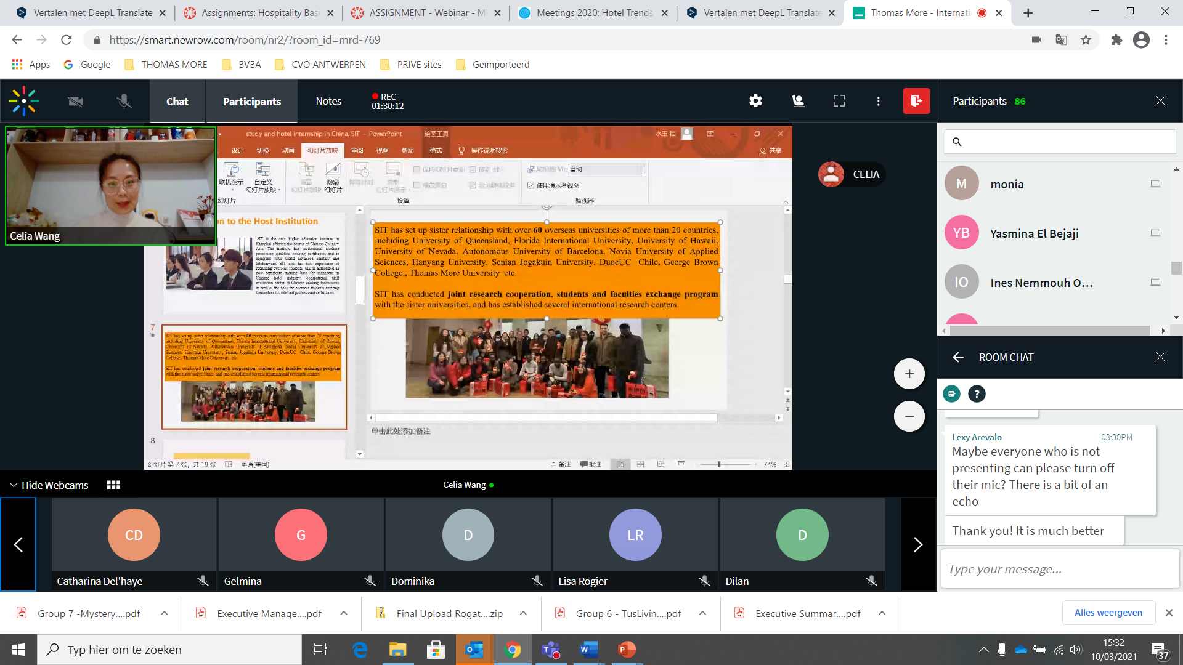

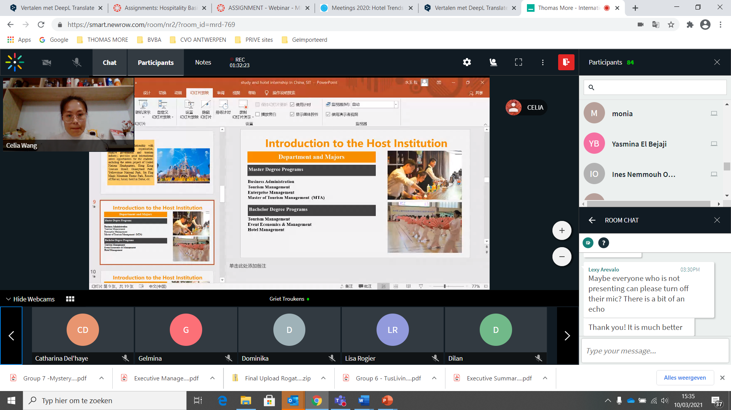

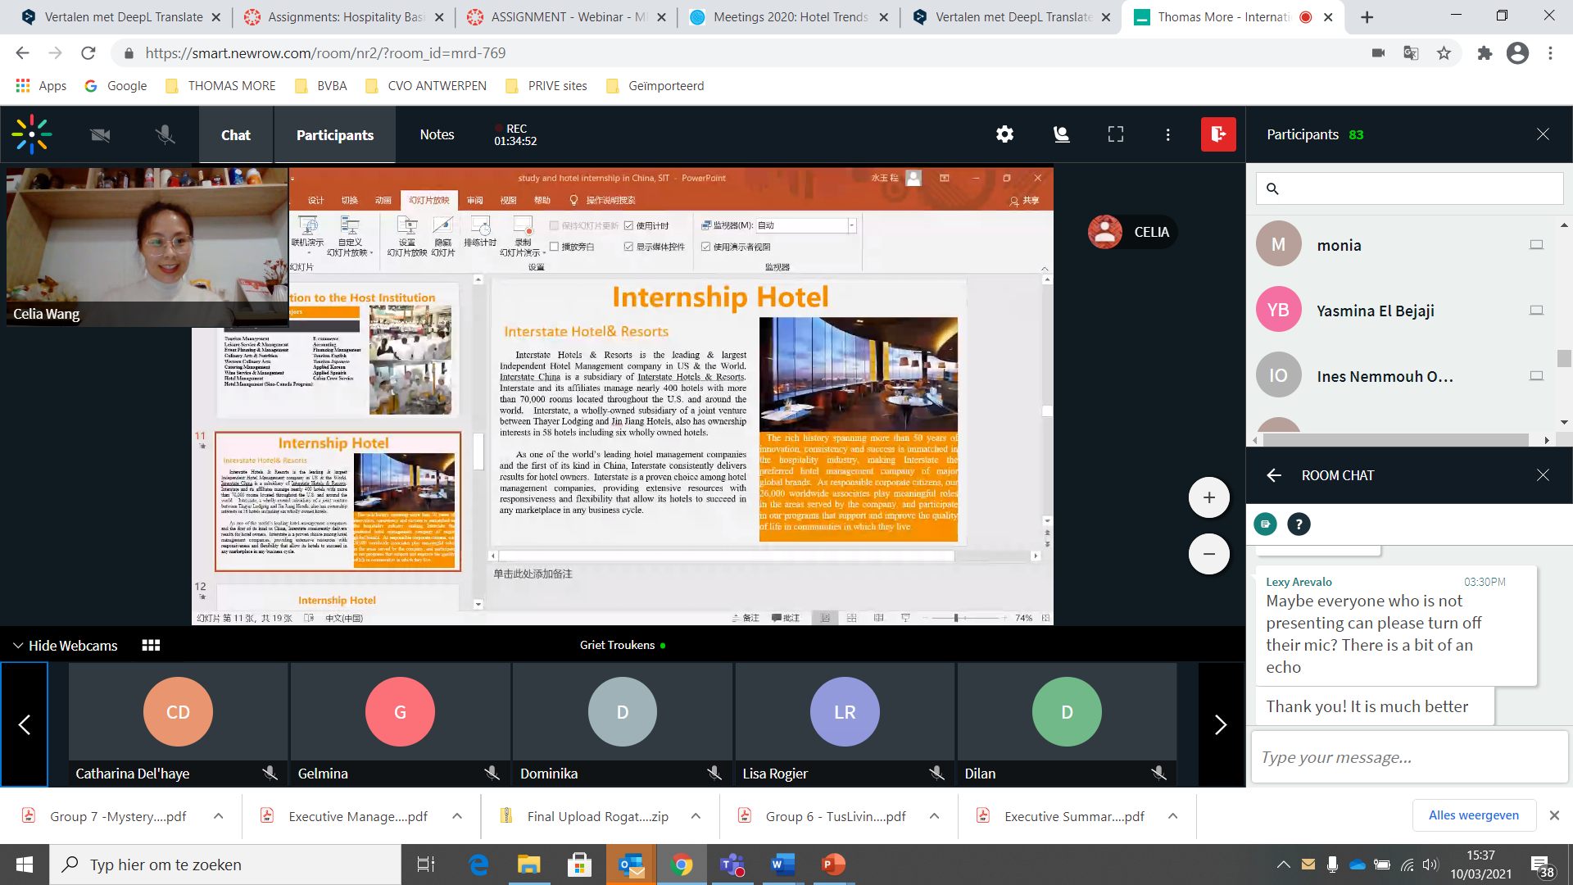

Contacts with Interstate hotel & resorts – hotel group – Hilton – largest independent management company US.

Double Tree by Hilton- TM students has done internship there.

Study on campus 2 weeks en then start internship!

F&B and Front Office or take turns.

Remuneration

Hotel offers room & dinner

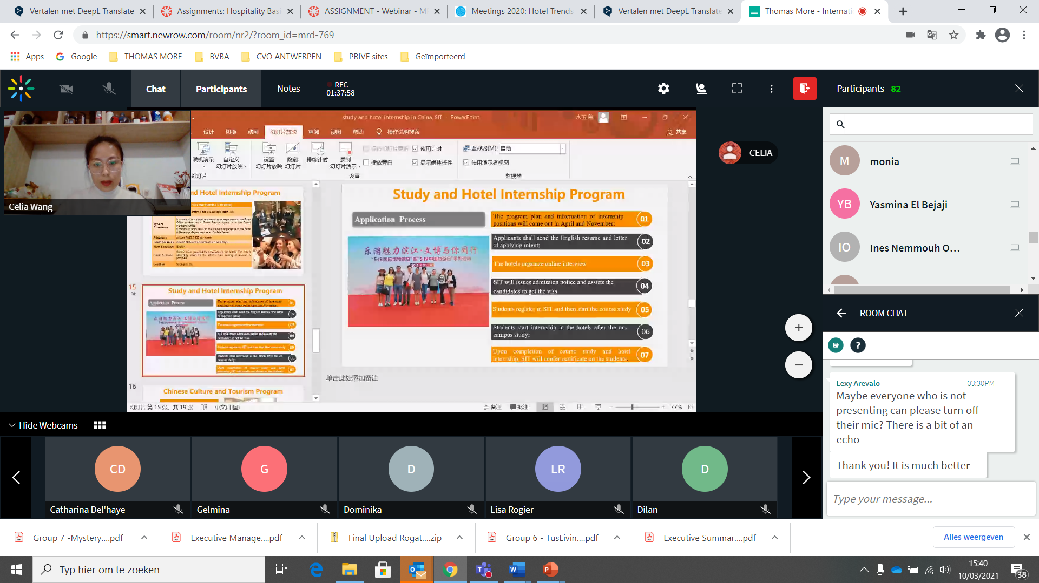

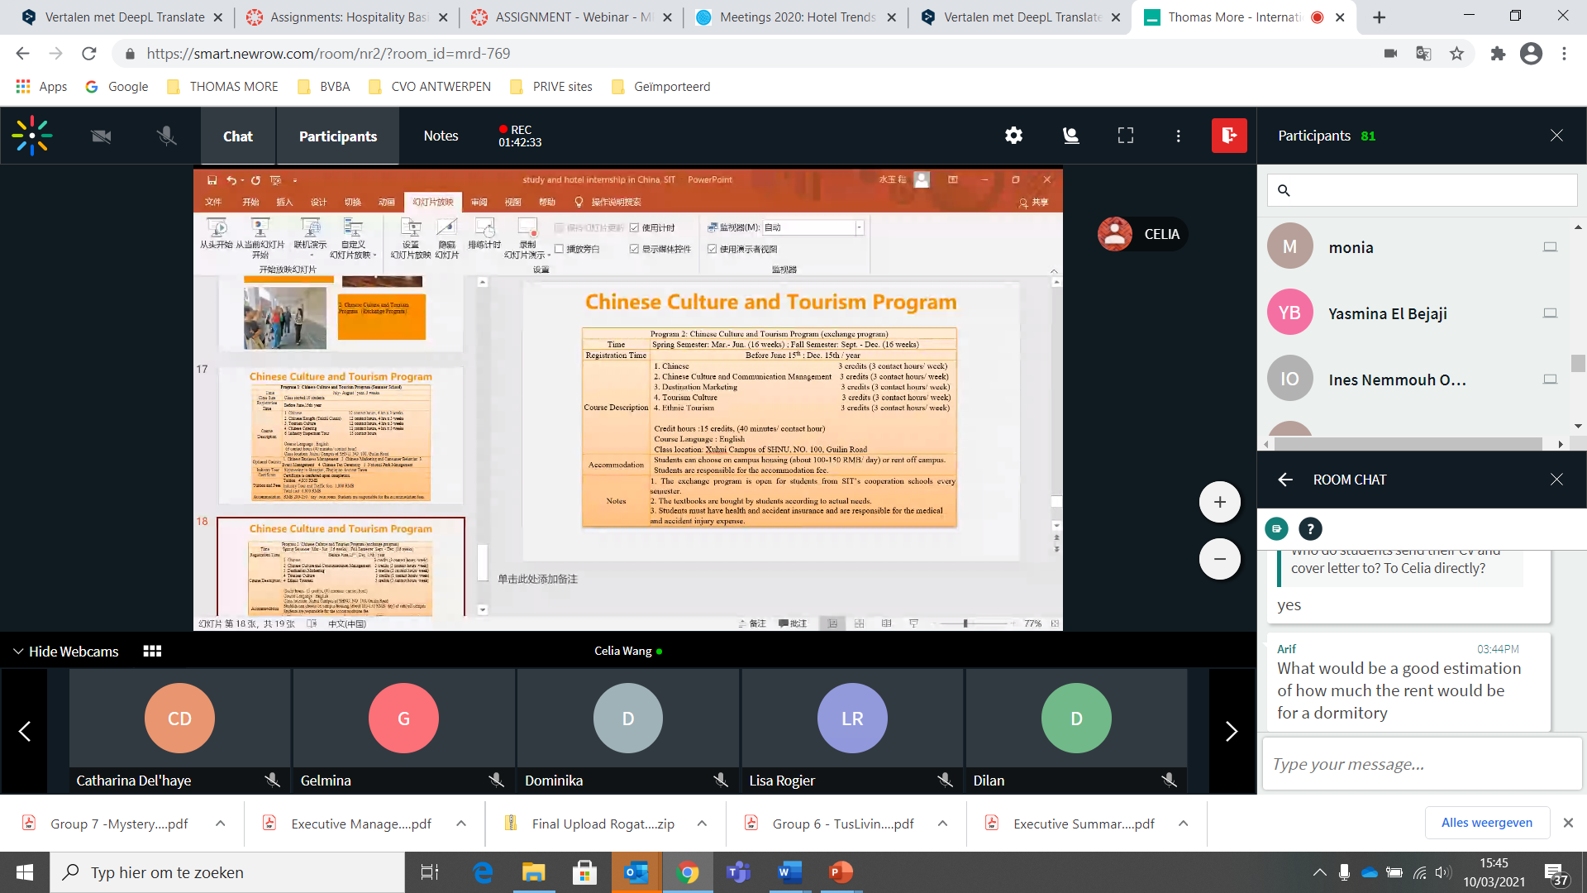

Cost for rent dormitory– approximately - 193 euro, = 1500 rMB

**For more information – contact Griet Troukens**, International Coordinator to get the contact details of the Celia Wang of Shanghai University as to how to apply for the programme and the internship opportunities linked to the University.