A-stay is a young start up hotel in Antwerpen with lots of technology integrated in a guest’s stay. It is a digitized focus hotel, a product between a hostel, a co-work and a traditional boutique design hotel.

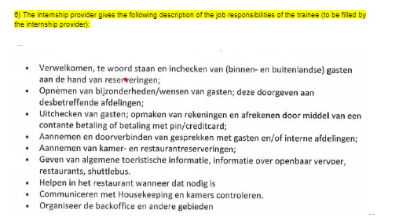

Website - <https://www.a-stay.com/nl/ons-verhaal/>

<https://www.a-stay.com/nl/when-co-living-meets-hotel-2/>